A comparative study of Regression algorithms on House Sales Price Prediction

K.S.Kalaivani,  Department of Artificial Intelligence,  Kongu Engineering College, kalaiprani123@gmail.com | C.S.Kanimozhiselvi,  Department of Artificial Intelligence,  Kongu Engineering College, kec.kanimozhi@gmail.com | Z.H.Mohamed Bilal,  Department of Artificial Intelligence,  Kongu Engineering College, mohamedbilalzh.21aim@kongu.edu | G.Sukesh,  Department of Artificial Intelligence,  Kongu Engineering College, sukeshg.21aim@kongu.edu | S.Yokeswaran,  Department of Artificial Intelligence,  Kongu Engineering College,  yokeswarans.21aim@kongu.edu

Abstract — Accurate prediction of house sales prices plays a pivotal role in various real estate and financial applications. As the real estate market continues to grow and evolve, it becomes increasingly important to employ advanced machine learning techniques to model and forecast housing prices. This research study presents a comprehensive study that investigates the performance of various regression algorithms like Linear Regression, Random Forest, Gradient Boosting and Extra-Trees for house sales price prediction. By examining a wide range of regression techniques, this study intends to identify the most effective algorithm for accurately predicting the household prices. Experiments are conducted to assess the models using Kaggle house prediction dataset, which has 1460 instances and 81 features. Feature extraction is done to select the most informative features. The results reveal that Extra-Trees outperform other regression methods with top 30 informative features.
Keywords— House Sales Price Prediction, Linear Regression, Random Forest, Gradient Boosting, Extra-Trees.

Introduction
The prediction of house sales prices has long been a subject of significant interest and research within the realms of real estate, finance, and economics. Accurate estimation of house prices not only benefits homebuyers and sellers but also plays a crucial role in investment decisions, property valuations, and mortgage lending. Over the years, researchers and practitioners have turned to machine learning algorithms to enhance the accuracy and reliability of price predictions.
The advent of advanced machine learning techniques, coupled with the availability of vast datasets, has opened up new avenues for developing robust predictive models. Regression algorithms, in particular, have gained widespread popularity due to their ability to capture the intricate relationships between various housing features and their corresponding prices. These algorithms can effectively learn from historical data and generalize patterns to make accurate predictions on unseen instances.
While numerous regression algorithms have been proposed in the literature, their relative performance and suitability for house sales price prediction remain largely unexplored. As such, this study aims to bridge the existing knowledge gap by conducting a comparative analysis of popular regression algorithms in the context of predicting house prices. By empirically evaluating and comparing the performance of multiple algorithms, we can shed light on their strengths, weaknesses, and suitability for this specific task.
The primary objective of this study is to guide researchers and practitioners in selecting the most suitable regression algorithm for house sales price prediction. By understanding the comparative performance of various algorithms, stakeholders in the real estate industry can make informed decisions and allocate resources efficiently. Furthermore, this study can serve as a benchmark for future research, enabling the development of more accurate and robust models for predicting house prices.
To achieve our goal, we used the Kaggle dataset containing a wide range of housing attributes, such as location, size, amenities, and neighborhood characteristics. This dataset encompasses diverse geographical regions and multiple housing markets to ensure the generalizability and applicability of our findings. We then apply a set of state-of-the-art regression algorithms, including linear regression, random forest, gradient boosting and Extra trees among others, to develop predictive models for house sales price estimation.
In the subsequent sections of this paper, we provide a detailed description of the regression algorithms considered, outline the experimental setup and methodology, and present our findings in terms of model performance metrics, such as mean absolute error, mean squared error, and R-squared. We also discuss the interpretability and computational complexity of the algorithms to provide a comprehensive analysis.
To estimate the price, we utilise Linear Regression, Random Forest, Gradient Boosting and Extra-Trees. Finally, the results are compared to identify which one is most effective for this process. When deploying a model, typically the parameters of the model play a vital role for the correct prediction and the best accuracy. So, inorder to choose the optimal parameters hyperparameter tuning is done by utilising the GridSearchCV package from the sklearn library. Using the optimal parameters can improve the accuracy of the model and produce better results. The contributions of this study are as follows:
i) Employ various regression algorithms for predicting the house sales price
ii)Utilize GridSearchCV for optimizing the hyperparameters
iii) Evaluate the performance of the regression algorithms used

Literature Survey
The increasing of housing cost and a thriving real estate market have left many people unsure about the type of home needed or the starting price for the ideal home. This subject has piqued the interest of researchers, and several people are currently working on it.
In various real-world scenarios, predicting the variance of house prices instead of a specific value is often more practical and desirable [1]. Researchers are exploring the application of Random Forest machine learning technology to forecast home prices. They have compared two approaches: machine learning and hedonic regression, to evaluate the accuracy of housing price prediction [2]. By utilizing random forest, real estate values can be estimated with an error rate of less than 2%. In contrast, hedonic regression models tend to be less accurate and focus on the key dwelling characteristics that significantly influence house prices. Non-linearities are often observed in these models, particularly when considering different price ranges.
The House Price Index (HPI) is a commonly used metric for assessing changes in housing prices [3]. Factors such as location, area, and population density play a significant role in determining home prices. HPI can also be employed to forecast individual housing prices, utilizing both traditional and advanced methodologies. In the field of general real estate valuation, computerized valuation has gained prominence [4]. A considerable amount of research has been devoted to comparing two models: multiple regression and neural networks, in order to address this issue. These models aim to provide accurate and efficient methods for property valuation.
The objective of this study is to develop simple yet accurate neural networks as a complement to technical approaches in predicting home prices [5]. The findings can be utilized independently or in combination with fundamental forecasts to gain insights into housing price trends and conduct policy analyses. Decision-makers often prefer empirical frameworks that are easy to implement and understand. Therefore, the researchers employ various regression techniques to forecast house prices [6]. Their methodology focuses on calculating home prices and offers more precise predictions and numerical approaches through machine learning. Given the significant impact of house prices on the economy, stakeholders such as customers and real estate agents are highly interested in accurate valuation [7]. Machine learning techniques have emerged as valuable tools for analyzing, predicting, and visualizing housing values, challenging the conventional assumptions. In this study, the XGBoost algorithm, a gradient boosting model, is used to predict home prices [8]. Accurate housing price forecasts contribute to economic growth, although this remains a challenging task that requires further research. The study proposes an enhanced gradient boosting (GB) model for improved home price prediction, particularly in complex real estate systems. Extensive testing is conducted using a publicly available real estate dataset to evaluate the proposed technique.

Studies focused on predicting home prices commonly utilize deep learning or machine learning models [9]. These models are trained using datasets, and their performance is compared to other machine learning-based models, including deep learning, attention models, extreme gradient boosting, and light gradient boosting. Resale housing has become increasingly prevalent in major cities due to population growth [10]. Researchers in this study forecast the resale price of houses using various classification techniques such as Logistic Regression, Decision Tree, Naive Bayes, and Random Forest. Additionally, the AdaBoost algorithm is employed to enhance weak learners and improve prediction accuracy.

The challenge of predicting property sale prices using predictive models remains complex [11]. To address this, regression techniques such as multiple linear regression, Lasso and Ridge regression models, support vector regression, and boosting algorithms like Extreme Gradient Boost Regression (XGBoost) are employed to build predictive models [12]. The performance of these models is compared to determine the most effective approach. Rising house prices are a significant global concern with implications beyond people's quality of life.
In this particular study, the researchers explore the use of an Artificial Neural Network (ANN) built on memristors to perform multi-variable regression and predict home prices [13]. The ANN is trained on labeled samples and can generate predictions through online training. Another approach employed in the study is Convolutional Neural Network (CNN), which is utilized for both house price forecasting and feature selection. The CNN model demonstrates improved performance in real estate transaction data tests.
The study evaluates the outcomes of different regression techniques, including Support Vector Regression, XGBoost, Decision Tree Regression, and Random Forest Regression [14]. The researchers select the approach that achieves the highest accuracy in predicting house values. The models are trained by considering various factors such as physical condition, location, amenities, financing rates, and other relevant aspects. Housing prices are subject to daily fluctuations and occasional inflationary tendencies, which complicate the valuation process [15]. However, the study aims to incorporate these essential factors, including pricing, into the assessment by utilizing regression algorithms to generate accurate predictions.
Due to the significant expansion of the housing market, the ability to forecast home prices is essential for individuals and businesses alike [16]. Consequently, the study proposes housing price prediction models based on both Backpropagation Neural Network (BPNN) and Convolutional Neural Network (CNN) deep learning techniques. These models are developed to enhance the accuracy and effectiveness of predicting housing prices.
Overall, the findings from the literature survey demonstrate the potential of regression algorithms and machine learning techniques in predicting house prices. The studies have contributed to advancements in understanding the housing market, aiding decision-makers, buyers, sellers, and real estate professionals in making informed choices. However, further research is needed to address the challenges associated with accurate house price prediction, including the incorporation of non-linearities, handling large-scale datasets, and considering dynamic market conditions.

Proposed Study
The dataset utilized in this study is available on Kaggle and consists of 1460 entries with 81 features. The target variable is "SalePrice." However, the dataset requires preprocessing as it contains null values and columns with object data instead of numerical values. These issues will be addressed during the data preprocessing stage. Figure 1 shows the flow diagram of the proposed study.
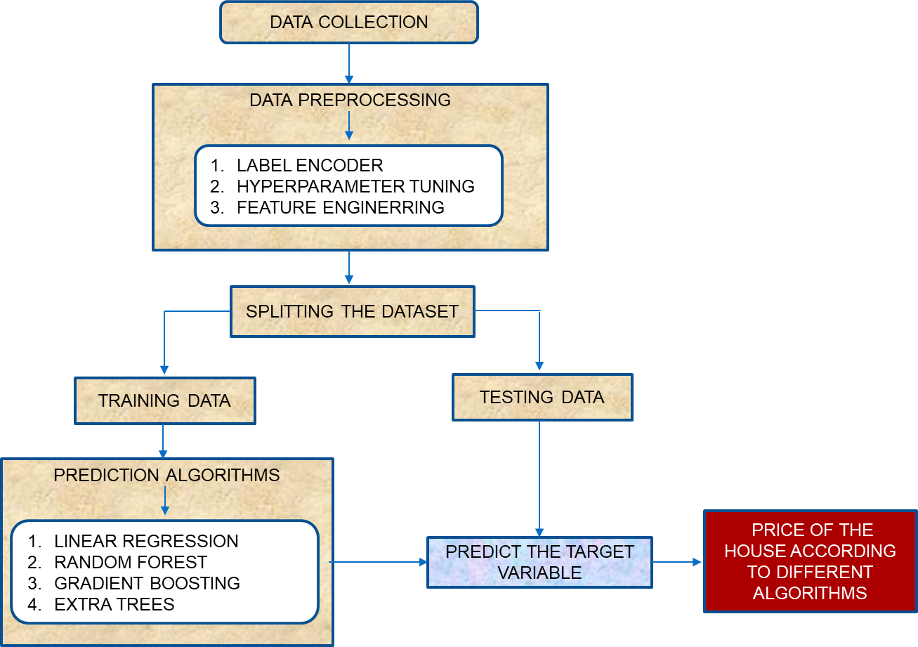
Fig 1. Flow diagram of the proposed study
To include the desired features and exclude unnecessary columns during data processing, feature extraction techniques will be applied. The goal is to identify the features that have the most significant impact on the target variable. These selected features will be incorporated into the models to compare their performance against a standard model in terms of accuracy and outcomes.
The dataset is divided into training and testing data sets using 80:20 ratio. Initially, different models are built using the training data, and their performance is evaluated using the testing data. The models are compared by visualizing their results through graphs.
Hyperparameter tuning plays a crucial role in improving model performance. Experiments are conducted with various parameter settings to identify the optimal values. For instance, the parameter "n_estimators" is important for algorithms such as Random Forest, Gradient Boosting, and Extra-Trees. By varying the value of n_estimators within a specified range, typically from 1 to 200, the best accuracy and outcomes can be obtained. Hyperparameter tuning requires substantial computational resources but helps in finding the optimal value of n_estimators for increased accuracy. The same approach can be applied to other algorithms to further enhance their performance. The Hyperparameter tuning description is given below in Table 1.
Table 1. Hyperparameters and their search space
Parameter | Search Space | Description
n_estimators | int | The number of trees in the forest.
criterion | squared_error, absolute_error, friedman_mse, poisson | The ability to assess a split's quality.
max_features | Sqrt, log2, None | The number of features to consider when looking for the best split
learning_rate | Values must be in the range [0.0, inf] | Learning rate shrinks the contribution of each tree by learning_rate.
max_depth | int or None | Maximum depth of the individual regression estimators.
subsample | Values must be in the range [0.0, 1.0] | The fraction of samples to be used for fitting the individual base learners.

The dataset used in this study contains several features with object-type data and null values. To preprocess the dataset, the next step involves addressing these issues. Among the 81 features, 43 are of object type. To handle these features, a label encoder is applied to convert the object data into numerical values. Additionally, for features with null values, the fillna() function is utilized to replace them with appropriate numerical values.
Since the dataset consists of 81 features, a feature extraction process is performed to identify the most important features and exclude the rest. The 'Id' feature, which does not contribute significantly to the dataset, has already been excluded. As a result, there remain 80 features after preprocessing. Through the feature extraction process, it becomes possible to determine which features have the highest contribution to the dataset.
Figure 2 illustrates the features that have the most significant contribution to the dataset. Based on this analysis, the top 30 attributes that strongly influence the target variable are selected for further implementation. This approach falls under the category of using feature extraction to enhance model performance.
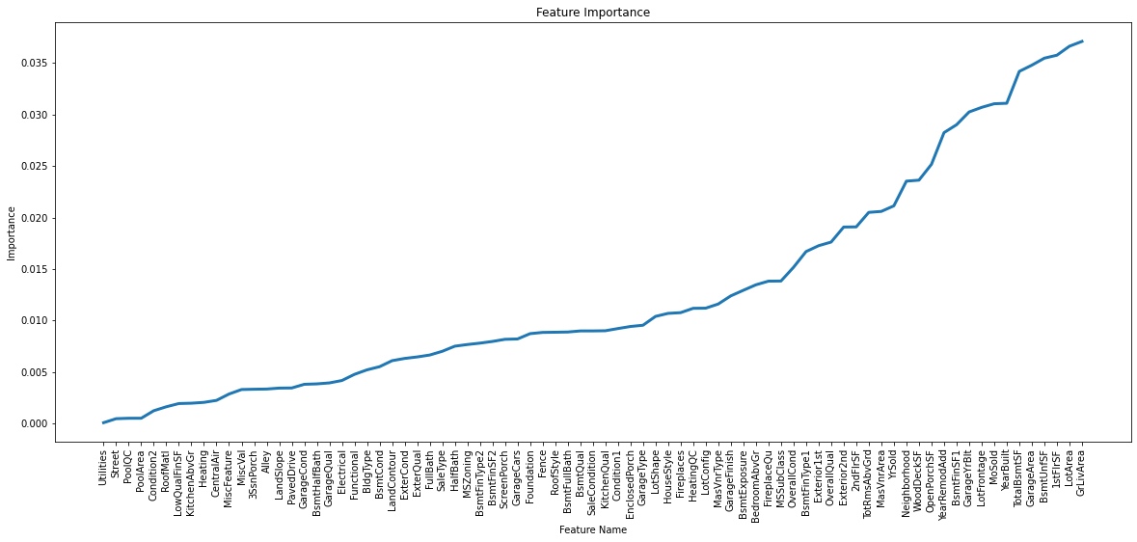
Fig 2. Feature Importance
Subsequently, four distinct algorithms are implemented in two different categories. The first category consists of a standard model, which does not involve feature extraction. The second category involves incorporating the selected top 30 attributes into the algorithms, leveraging the benefits of feature extraction.
Error Metrics
For this dataset, to determine the accuracy and error, there are about for types of error metrics like R2 score, Mean Absolute Error, Root Mean Squared Error and Median Absolute Percentage Error of the models. Except Median Absolute Percentage Error, all other errors metrics are already available at Sklearn metrics package. The formula used to determine the mentioned error metrics.
Table 2. Formulae of different metrics used
ERROR METRICS | FORMULA
R² SCORE | 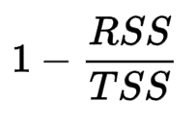
MEAN ABSOLUTE ERROR [MAE] | 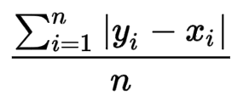
ROOT MEAN SQUARED ERROR [RMSE] | 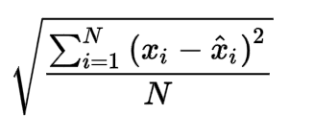
MEDIAN ABSOLUTE PERCENTAGE ERROR [MDAPE] | Median(|actual-predicted|/actual) *100
The dataset is processed using two methods: one with feature extraction and the other without feature extraction. In both cases, several algorithms are employed, including Linear Regression, Random Forest, Gradient Boosting, and Extra-Trees. The first set of models is built without feature extraction, while the second set incorporates feature extraction techniques.
To evaluate the performance of the models, the Actual versus Predicted values are plotted. This allows for visual comparison and analysis of the models' predictive capabilities. Additionally, the models are compared using evaluation metrics such as R2 score, Mean Absolute Error (MAE), Root Mean Squared Error (RMSE), and Median Absolute Percentage Error (MAPE). These metrics provide insights into the accuracy and effectiveness of the models in predicting house prices.
A. LINEAR REGRESSION
Linear regression is a widely used statistical method for modeling the relationship between a dependent variable and one or more independent variables. It assumes that there is a linear association between the independent variables and the dependent variable, implying that changes in the independent variables cause proportional changes in the dependent variable. The primary objective of linear regression is to minimize the sum of squared differences between the actual values and the predicted values by fitting a line to the observed data points. This enables researchers to make predictions and draw inferences about the strength, relevance, and nature of the relationships. Linear regression finds applications in various fields, including economics, social sciences, and machine learning. It is employed to analyze and forecast numerical outcomes based on input features. By employing linear regression, researchers can gain insights into the factors influencing the dependent variable and make predictions about its values in different scenarios.
B. RANDOM FOREST
Random Forest is a highly popular machine learning algorithm that is commonly used for both classification and regression tasks. It belongs to the ensemble learning category, which involves combining multiple individual classifiers or models to enhance overall performance. In the case of Random Forest, the algorithm constructs multiple decision trees, each trained on a random subset of the data. These decision trees collectively form the forest. During the training process, each tree in the forest makes predictions on the target variable based on the given input features.
To obtain the final prediction from the Random Forest, each tree's prediction is taken into account through a voting mechanism. For classification problems, the mode (most frequent class prediction) is used, while for regression problems, the average or median prediction is often used. The majority voting or averaging process helps to reduce the impact of individual tree biases and errors, leading to a more robust and accurate prediction. Random Forest has gained popularity due to its ability to handle complex relationships in the data, handle high-dimensional feature spaces, and effectively deal with overfitting.
C. GRADIENT BOOSTING
Machine learning has emerged as a prominent technology for building prediction models to address complex regression and classification problems. Among the various techniques used in machine learning, gradient boosting stands out as one of the most effective boosting algorithms. Boosting methods have gained significant popularity within the global machine learning community. Boosting techniques utilize the concept of ensemble learning, where multiple weak learners or base estimators are combined to generate the final output. The boosting strategy iteratively trains a sequence of weak learners, with each subsequent model attempting to correct the mistakes made by its predecessors. This iterative process results in the creation of a strong learner or a highly accurate predictive model.
Gradient boosting, specifically, is a type of boosting algorithm that leverages the concept of gradients to improve the learning process. It uses the gradient information to identify the direction in which the subsequent models need to be trained to minimize the loss function. By continuously adjusting the weights or parameters of the weak learners, gradient boosting transforms them into stronger learners capable of making accurate predictions. The application of gradient boosting as an ensemble strategy in machine learning has demonstrated remarkable performance in various domains. It has proven effective in handling complex relationships and capturing intricate patterns within the data. The ability to transform weak learners into strong ones through iterative training contributes to the success of gradient boosting.
D. EXTRA-TREES
The Extra Trees Classifier is a powerful ensemble learning technique that combines the predictions of multiple decision trees to produce a classification result. It forms part of the broader family of tree-based ensemble methods, such as Random Forests. When constructing each decision tree in the Extra Trees Classifier, a random subset of features is selected from the original training sample. This subset typically consists of a fixed number of features known as "k." From this subset, the decision tree chooses the best feature to split the data at each node. This randomization aspect helps to decorrelate the individual decision trees and adds an extra layer of randomness to the ensemble.
To evaluate the importance of each feature in the Extra Trees Classifier, the Gini Importance measure is computed. The Gini Importance quantifies the extent to which a feature contributes to reducing impurity (Gini index) in the decision tree splits. The higher the Gini Importance of a feature, the more relevant it is for making accurate predictions. Once the Gini Importance is calculated for each feature, they are ranked in descending order. This ranking allows for identifying the most important features that have the greatest impact on the classification outcomes. By considering these top-ranked features, the Extra Trees Classifier can make informed decisions and achieve high classification accuracy.

Results and Discussion
Table 3 and Figure 4 show the results of the different algorithms, along with their corresponding error metrics. The algorithms using feature extraction generally perform better in terms of R2 score, indicating a higher level of explained variance in the predictions. Gradient Boosting, both with and without feature extraction, consistently shows the highest R2 score, suggesting it captures the relationship between the features and target variable more effectively. Random Forest and Extra-Trees also perform well, but their R2 scores are slightly lower than Gradient Boosting. Linear Regression, although simpler compared to ensemble methods, still provides decent predictions but has the lowest R2 score. When feature extraction is applied, all algorithms show improvements in various error metrics, including MAE, RMSE, and MDAPE, indicating enhanced accuracy and reduced prediction errors. Extra-Trees with feature extraction exhibits the highest R2 score among all the algorithms, closely followed by Gradient Boosting with feature extraction. Gradient Boosting with feature extraction and Extra-Trees with feature extraction appear to be the most promising algorithms, as they consistently yield the highest R2 scores and lower errors across multiple metrics.
Table 3. Error obtained using various metrics
ALGORITHM USED | ERROR METRICS
ALGORITHM USED | R² SCORE | MAE | RMSE | MDAPE
Linear Regression | 0.8226 | 19707.30 | 35566.38 | 8.11
Random Forest | 0.8882 | 16446.20 | 28232.84 | 6.63
Gradient Boosting | 0.9104 | 15282.86 | 25268.41 | 6.57
Extra-Trees | 0.8763 | 16254.55 | 29695.29 | 6.30
Linear Regression [Using Feature Extraction] | 0.8417 | 19805.50 | 33591.31 | 8.44
Random Forest [Using Feature Extraction] | 0.9038 | 16409.94 | 26190.97 | 6.45
Gradient Boosting [Using Feature Extraction] | 0.9244 | 15289.42 | 23206.63 | 6.77
Extra-Tree [Using Feature Extraction] | 0.9261 | 15107.62 | 22944.64 | 6.11

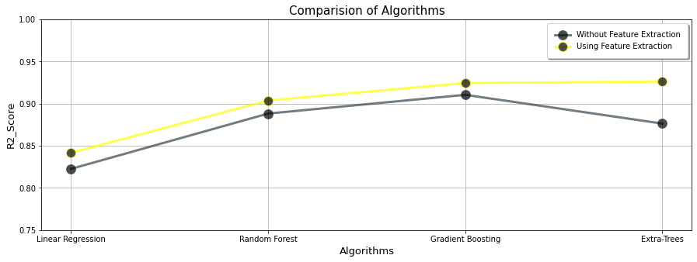
Fig 4. Analysis of R² SCORE of several algorithms

Conclusion and Future Work
In this comprehensive study, we conducted a thorough comparison of regression algorithms for predicting house sales prices. Our objective was to identify the most effective algorithm for accurately estimating house prices by evaluating their performance on a diverse dataset representing different housing markets and attributes. Through our experiments, we obtained valuable insights into the strengths and weaknesses of various regression algorithms. Our findings indicate that certain algorithms consistently outperformed others in terms of predictive accuracy. Among them, Extra Trees stood out with a remarkable R2 score of 0.9261. This algorithm demonstrated superior performance by effectively capturing the complex nonlinear relationships between housing features and prices, resulting in highly accurate predictions. By selecting Extra Trees as the preferred regression algorithm, we can have increased confidence in estimating house sales prices. This algorithm's ability to handle complex relationships and deliver precise predictions can greatly benefit real estate professionals, buyers, and sellers in making informed decisions.

References
- Abigail Bola Adetunji, et al. (2022). "House Price Prediction using Random Forest Machine Learning Technique." Procedia Computer Science, 199, 806-813.
- Juan Ramón Rico-Juan, and Paloma Taltavull de La Paz (2021). "Machine learning with explainability or spatial hedonics tools? An analysis of the asking prices in the housing market in Alicante, Spain." Expert Systems with Applications, 171, 114590.
- Quang Truong, et al. (2020). "Housing price prediction via improved machine learning techniques." Procedia Computer Science, 174, 433-442.
- Iwona Foryś (2022). "Machine learning in house price analysis: regression models versus neural networks." Procedia Computer Science, 207, 435-445.
- Xiaojie Xu, and Yun Zhang (2021). "House price forecasting with neural networks." Intelligent Systems with Applications, 12, 200052.
- Mansi Jain, et al. (2020). "Prediction of house pricing using machine learning with Python." In 2020 International Conference on Electronics and Sustainable Communication Systems (ICESC). IEEE.
- Maida Ahtesham, Narmeen Zakaria Bawany, and Kiran Fatima (2020). "House price prediction using machine learning algorithm-the case of Karachi city, Pakistan." In 2020 21st International Arab Conference on Information Technology (ACIT). IEEE.
- Bandar Almaslukh (2020). "A Gradient Boosting Method for Effective Prediction of Housing Prices in Complex Real Estate Systems." In 2020 International Conference on Technologies and Applications of Artificial Intelligence (TAAI). IEEE.
- Pei-Ying Wang, et al. (2021). "Deep learning model for house price prediction using heterogeneous data analysis along with joint self-attention mechanism." IEEE Access, 9, 55244-55259.
- P. Durganjali, and M. Vani Pujitha (2019). "House resale price prediction using classification algorithms." In 2019 International Conference on Smart Structures and Systems (ICSSS). IEEE.
- J. Manasa, Radha Gupta, and N. S. Narahari (2020). "Machine learning based predicting house prices using regression techniques." In 2020 2nd International conference on innovative mechanisms for industry applications (ICIMIA). IEEE.
- Yong Piao, Ansheng Chen, and Zhendong Shang (2019). "Housing price prediction based on CNN." In 2019 9th international conference on information science and technology (ICIST). IEEE.
- J. J. Wang, et al. (2018). "Predicting house price with a memristor-based artificial neural network." IEEE Access, 6, 16523-16528.
- Vivek Singh Rana, et al. (2020). "House Price Prediction Using Optimal Regression Techniques." In 2020 2nd International Conference on Advances in Computing, Communication Control and Networking (ICACCCN). IEEE.
- Ayush Varma, et al. (2018). "House price prediction using machine learning and neural networks." In 2018 second international conference on inventive communication and computational technologies (ICICCT). IEEE.
- Choujun Zhan, et al. (2020). "Housing prices prediction with deep learning: an application for the real estate market in Taiwan." In 2020 IEEE 18th International Conference on Industrial Informatics (INDIN). IEEE.

